IT24100842

K.A.D.J.W.C. Abeywardena

Labsheet 08

Q1.

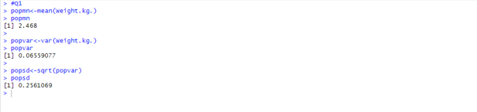

Q2.

Q3.



